Appendix II: Student Application Data
Please complete the below table(s) according to instructions on pages 2-3 to reflect the number of applications received for open enrollment and post enrollment. Use one table per applicable grade level.

 | Grade Level:_______
 | 2018-2019 School Year | 2019-2020 School Year
Open Enrollment
Post Enrollment
Seats

 | Grade Level:_______
 | 2018-2019 School Year | 2019-2020 School Year
Open Enrollment
Post Enrollment
Seats

 | Grade Level:_______
 | 2018-2019 School Year | 2019-2020 School Year
Open Enrollment
Post Enrollment
Seats

Appendix II Instructions
- Please read the Prop 39 Facilities Request Form Instructions to determine if your school must submit Appendix II: Student Application Data.

- You must have a login to SchoolMint and access to Microsoft Excel to obtain the required information for Appendix II.

- If your school is unable to access the following information or does not use SchoolMint, Enroll Oakland is available to generate the required data on your school’s behalf. Please contact: operations@enrolloak.org.

Directions for obtaining the information required for Appendix II: Student Application Data:
- Login to https://enrolloak.schoolmint.net using your SchoolMint credentials.

- Ensure the correct <School Year Enrollments> is selected at the top right of the screen.
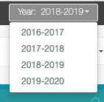

- Select the Application Index from the navigation bar.

- Select the appropriate <School> from the Schools drop down (if your organization has multiple schools) and <Transition Grade(s)> from the Grades drop down. Click the Search button on the far right of the screen. (Please confirm that TK and K are separate, if applicable)
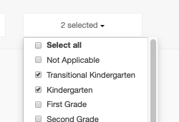

- Once all results are displayed (Showing 1 to 25 of X entries stops increasing), select Export as CSV XLS button on the left side of the screen above Student Name.

- Open the downloaded file named StudentApplications (#).

- In the downloaded Excel file, complete the following steps:

  - Go to column W submission_date and delete any rows with PE submission dates after 7/31 for current year enrollments (for example Year 2018-2019 enrollments, delete rows with submission_date from 8/1/2019 through 8/1/2020).

  - Count the number of Open Enrollment (also called Round 1 or On Time) applications in column U application_type “OE” (you can also use a filter to do this). Insert the number in the “Open Enrollment” row of the table in Appendix II.

  - Count the number of Post Enrollment (also called Round 2 or Late) applications in column U application_type “PE” (you can also use a filter to do this). Insert the number in the “Post Enrollment” row of the table in Appendix II.

- Back in SchoolMint, navigate to Admissions -> Open Seats Setup
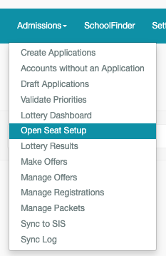

- Choose the correct school in the Select School drop down (if your organization has multiple schools).

- Locate the Budgeted seats from the Open Seat Setup screen for <Transition Grade(s)>. Insert this number into the “Seats” row of the table in Appendix II.
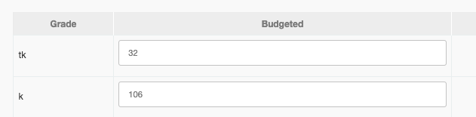

- Repeat steps 1-10 for each grade level required per the Prop 39 Facilities Request Form Instructions.

