Material Revision
Change of School Location/New School Facility Application

Name of School

Grades Served

Current Address

New Address

Proposed Occupancy Date

Please note, schools in Year 1 of operation do not need to submit a Material Revision but will need to meet/submit the requirements as listed.

Material Revision Summary

In 2-pages or less, please describe the following:
- reason/rationale for changing the school location
- school/neighborhood community engagement regarding the new school location
- financial costs of the project and the resources available to fulfill these

District Required Language

Please include the following language within the material revision of the “Facilities Plan” portion of the charter petition. Please submit a redlined version AND final version of the material revision pertinent to the “Facilities Plan” only.

“[INSERT SCHOOL NAME] shall occupy facilities that comply with the Asbestos requirement as cited in the Asbestos Hazard Emergency Response Act (AHERA), 40CFR part 763. AHERA requires that any building leased or acquired that is to be used as a school or administrative building shall maintain an asbestos management plan.”

“If [INSERT SCHOOL NAME] fails to submit a certificate of occupancy or other valid documentation to the District verifying that the intended facility in which the school will operate complies with Education Code Section 47610, not less than 30 days before the school is scheduled to begin operation pursuant to the first year of this renewal term, it may not commence operations unless an exception is made by the Office of Charter Schools and/or the local planning department or equivalent agency. If [INSERT SCHOOL NAME] moves or expands to another facility during the term of this charter, [INSERT SCHOOL NAME] shall provide a certificate of occupancy or other valid documentation to the District verifying that the intended facility in which the school will operate complies with Education Code Section 47610, to the District for each facility at least 30 days before school is scheduled to begin operations in the facility or facilities. [INSERT SCHOOL NAME] shall not begin operation in any location for which it has failed to timely provide a certificate of occupancy to the District, unless an exception is made by the Office of Charter Schools and/or the local planning department or equivalent agency. Not withstanding any language to the contrary in this charter, the interpretation, application, and enforcement of this provision are not subject to the Dispute Resolution Process.”

[INSERT SCHOOL NAME] will provide the following evidence that the facility complies with the following legal requirements prior to occupying the property*:
- Zoning: The location of the school meets local zoning requirements.
- Building Code: Each building on the site meets applicable building code requirements.
- The charter school has considered and met all requirements of the California Environmental Quality
Act (i.e. proof of Environmental Review).
- The proposed site has adequate classroom space, non-classroom space and specialized teaching space
for the enrollment levels to be housed at the site.
- Compliance with California Department of Education regulations regarding safety factors for school
site, including proximity to airports, high-voltage power lines, hazardous air emissions, railroads, high-
pressure natural gas lines, gasoline lines, pressurized sewer lines and other high-pressure water
pipelines, propane tanks, noise, major roadways, geological studies and soils analysis, traffic safety,
and safe routes to the school.

[INSERT SCHOOL NAME] will schedule a walk-through of the new facility with the Office of Charter Schools to take place at last two weeks in advance of the proposed date of student occupancy. The following check-list items will be fulfilled (see next page).

*Please note, all schools should refer to and comply with all of the regulations listed on the CDE website. To download the CDE's School Site Selection Checklist, click here.
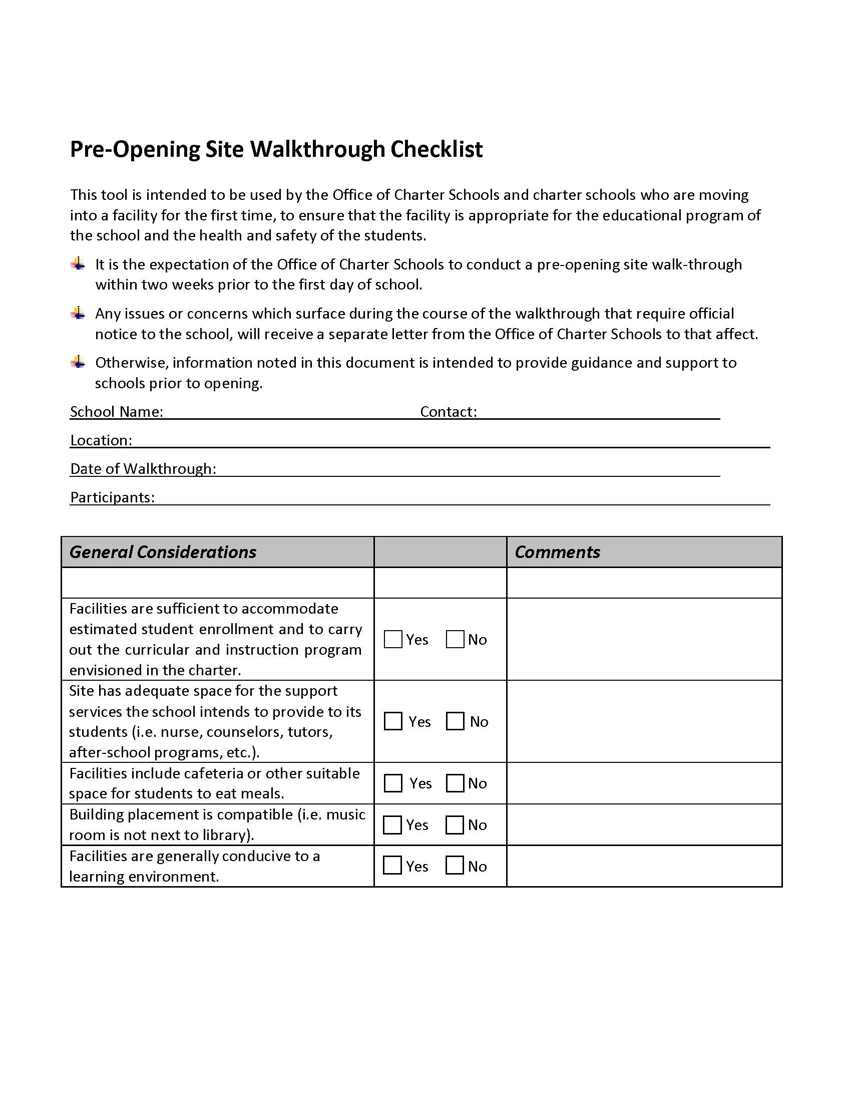
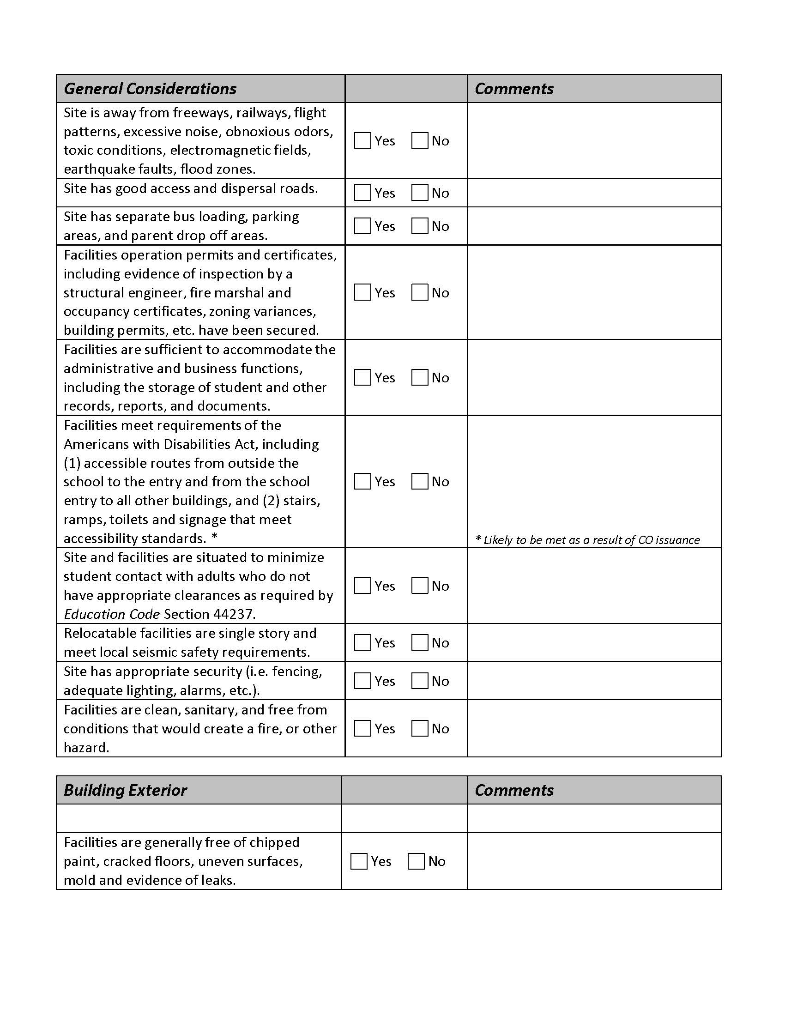
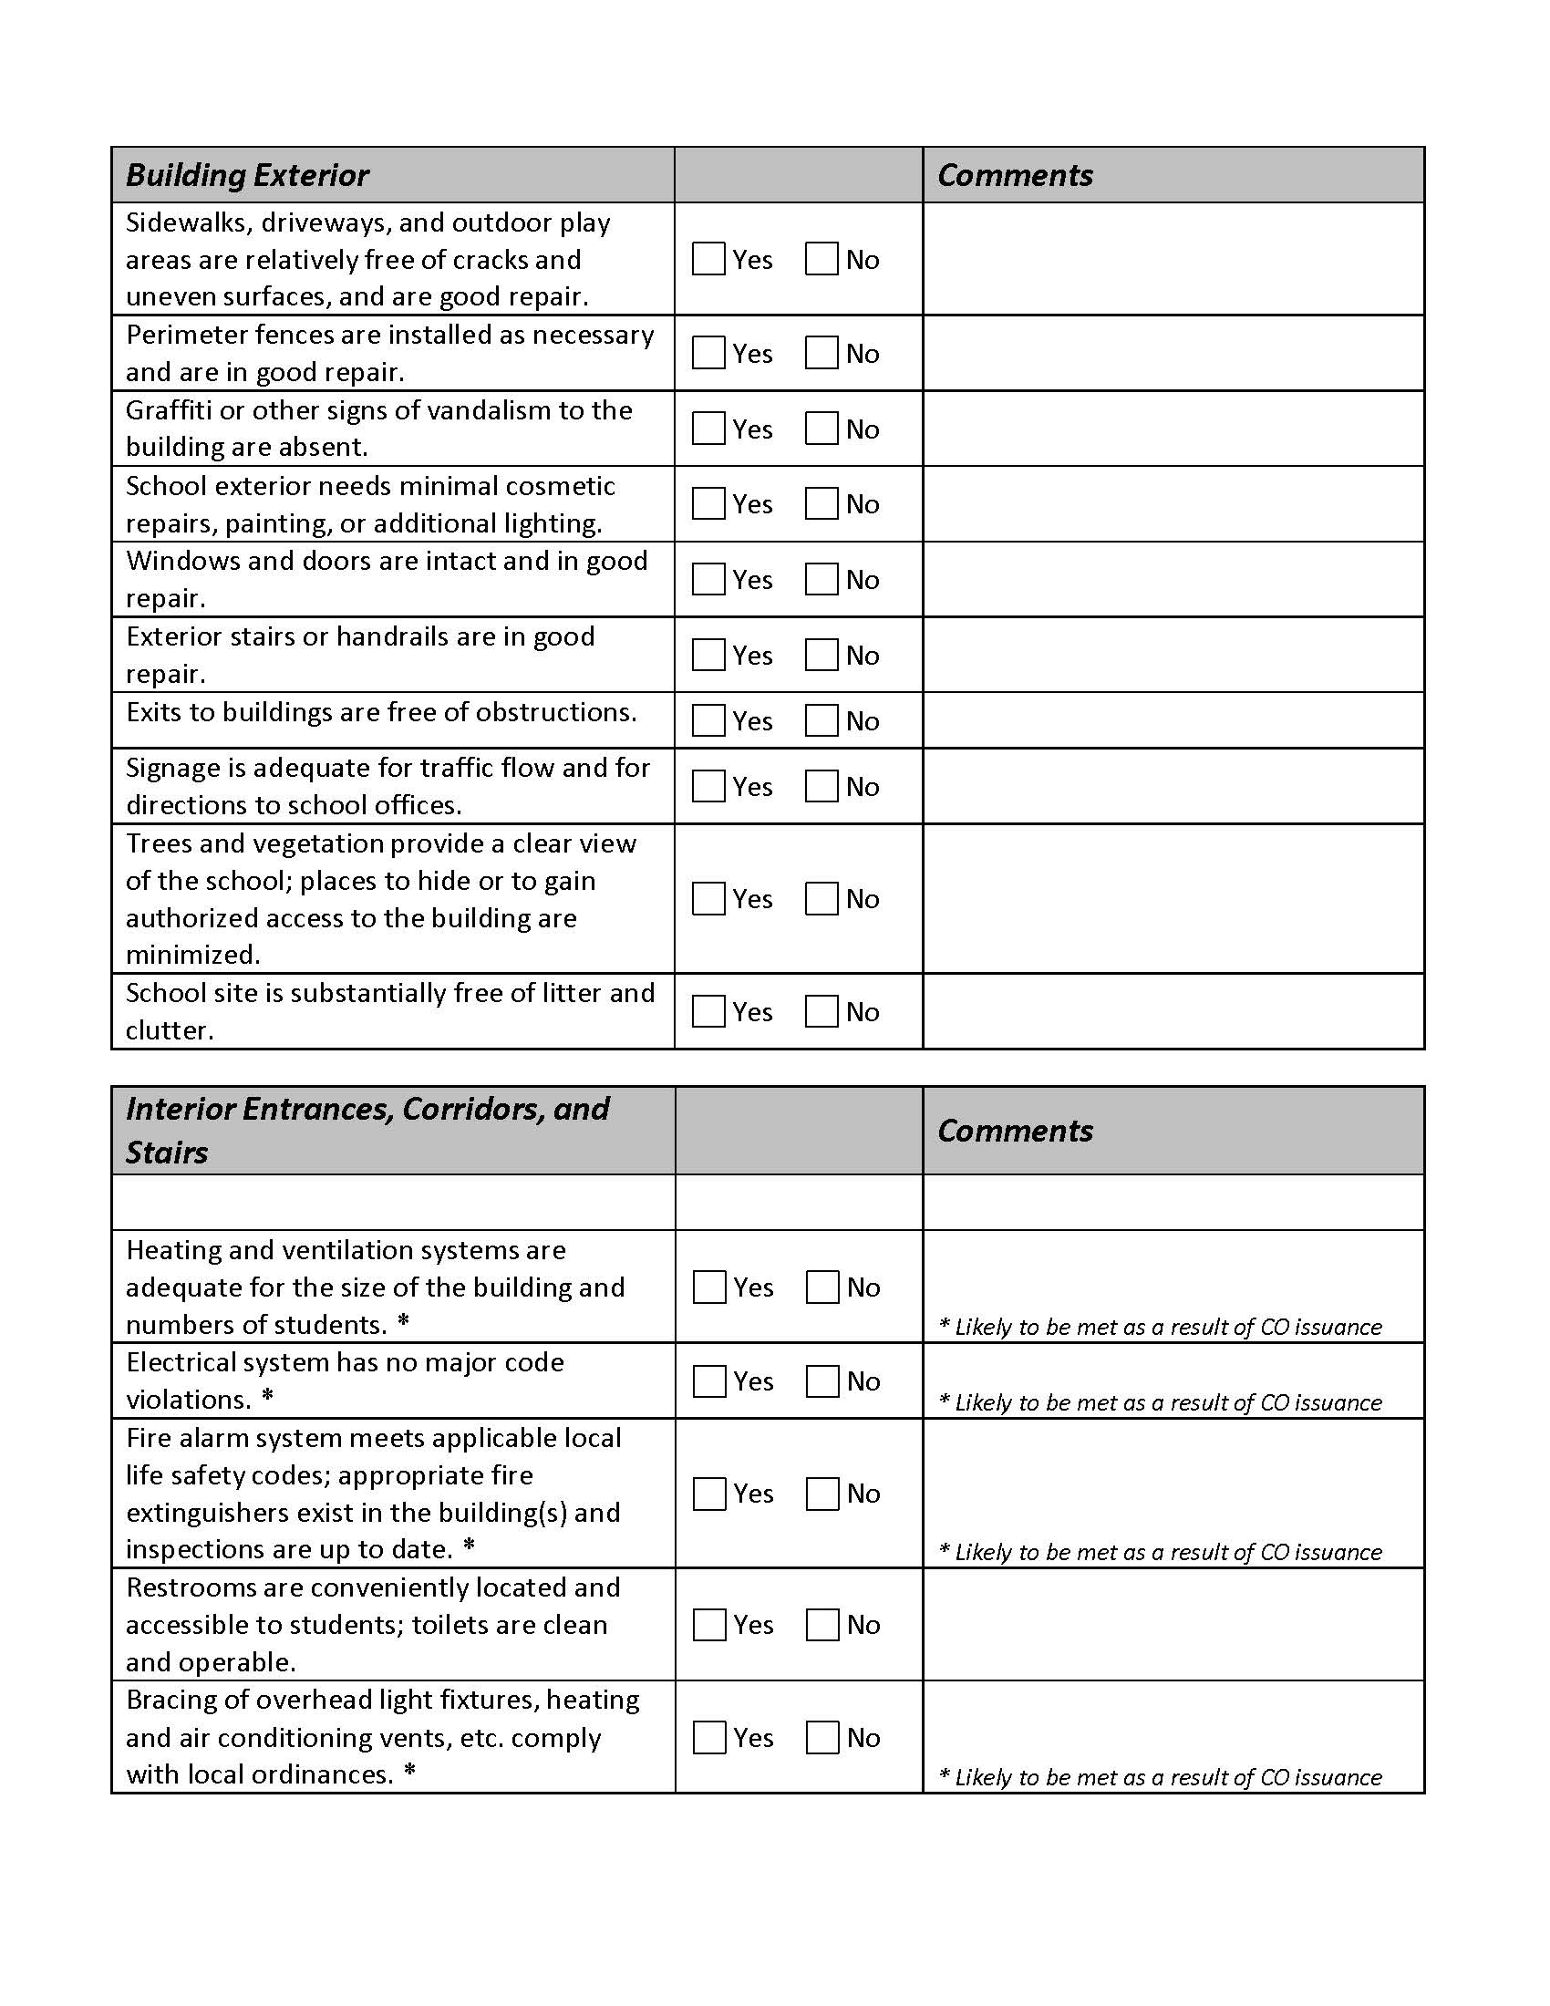
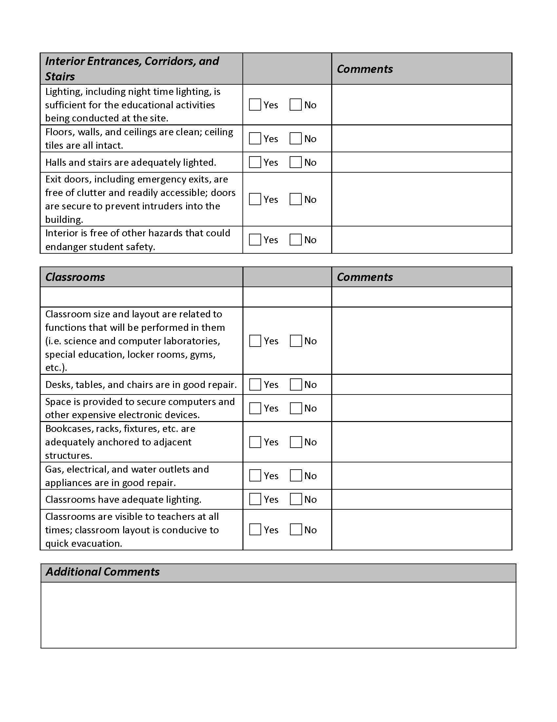

Facilities Plan Material Revision
Submission Process

The charter school shall submit three (3) hard copies and one (1) electronic copy of the following documents at a regularly scheduled board meeting:

- completed application
- material revision summary (2 pages or less)
- redlined AND final version of the “Facilities Plan” portion of the petition ONLY; to include the “Required Text and Assurances” listed in the application, as well as taking into consideration the elements of evaluation (see evaluation tool below).

Within 30 days of the material revision being submitted, a public hearing will be scheduled where a school representative will make a brief presentation to the OUSD Board of Education (BOE). Within 60 days of the material revision being submitted, a decision will be made by the OUSD BOE at a regularly scheduled board meeting.

Facilities Plan Evaluation Tool

Non-district facility
A description of the plan for using a non-district facility excels if it has the following characteristics:
- Informed assessment of school’s facility needs;
- Estimated costs for facility based on research and evidence;
- Adequate budget for facility costs including renovation, rent, maintenance and utilities;
- Identified funding sources for facility; and
- An assurance of legal compliance (CA Environmental Quality Act, health and safety, ADA, and applicable building codes);

If the school site location has yet to be determined, please include the following additional information:
- A description of potential sites including location, size and resources;
- Informed analysis of the viability of potential sites; and
- A schedule for securing a facility including the person responsible for implementation

Facility Plan:
Inadequate | Approaches | Meets | Excels

