Appendix II Instructions
Please read the Prop 39 Facilities Request Form Instructions to determine if your school must submit Appendix II: Student Application Data.

You must have a login to SchoolMint and access to Microsoft Excel to obtain the required information for Appendix II.

If your school is unable to access the following information or does not use SchoolMint, Enroll Oakland is available to generate the required data on your school’s behalf. Please contact: operations@enrolloak.org.

Directions for obtaining the information required for Appendix II: Student Application Data:
- Login to https://enrolloak.schoolmint.net using your SchoolMint credentials.

- Ensure the correct <School Year Enrollments> is selected at the top right of the screen.
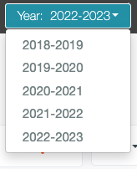

- Select the Application Index from the navigation bar.
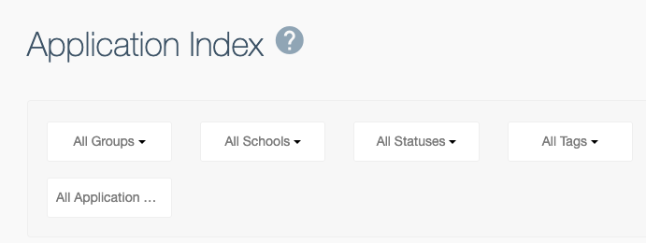

- Select the appropriate <School> from the Schools drop down (if your organization has multiple schools) and <Transition Grade(s)> from the Grades drop down. Click the Search button on the far right of the screen. (Please confirm that TK and K are separate, if applicable)
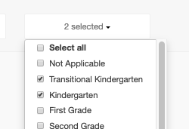

- Once all results are displayed (Showing 1 to 25 of X entries stops increasing), select Export as CSV XLS button on the left side of the screen above Student Name.
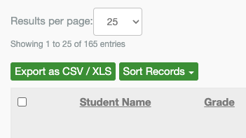

- Open the downloaded file named "StudentApplications.csv".

- In the downloaded Excel file, complete the following steps:

  - Go to column W submission_date and delete any rows with Post Enrollment submission dates after 7/31 for current year enrollments (for example Year 2018-2019 enrollments, delete rows with submission_date from 8/1/2018 through 8/1/2019).

  - Count the number of Open Enrollment (also called Round 1 or On Time) applications in column U application_type “OE” (you can also use a filter to do this). Copy this number count in the “Open Enrollment” row of the table in Appendix II.

  - Count the number of Post Enrollment (also called Round 2 or Late) applications in column U application_type “PE” (you can also use a filter to do this). Copy this number count in the “Post Enrollment” row of the table in Appendix II.

- Back in SchoolMint, navigate to Admissions -> Open Seats Setup
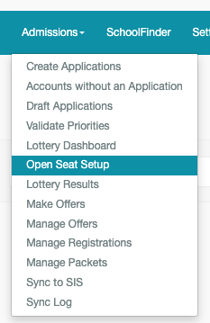

- Choose the correct school in the Select School drop down (if your organization has multiple schools).

- Locate the Budgeted seats from the Open Seat Setup screen for <Transition Grade(s)>. Copy this number into the “Seats” row of the table in Appendix II.
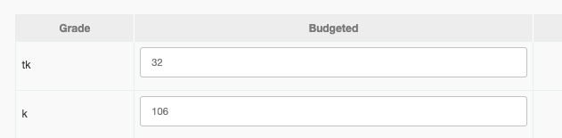

- Repeat steps 1-10 for each grade level required per the Prop 39 Facilities Request Form Instructions.

Appendix II: Student Application Data
Please complete the below table(s) according to instructions on pages 1-2 to reflect the number of applications received for open enrollment and post enrollment. Use one table per applicable grade level. Most schools will only need to fill out one of the below table, but three are provided for different grade levels if needed.

 | Grade Level:_______
 | 2022-2023 School Year | 2023-2024 School Year
Open Enrollment
Post Enrollment
Seats

 | Grade Level:_______
 | 2022-2023 School Year | 2023-2024 School Year
Open Enrollment
Post Enrollment
Seats

 | Grade Level:_______
 | 2022-2023 School Year | 2023-2024 School Year
Open Enrollment
Post Enrollment
Seats

